Supplier Database

show databases;

create database SupplierDatabase_157;

use SupplierDatabase_157;

create table Supplier_157 (

Sid int,

SName varchar(20),

City varchar(20),

primary key (Sid));

create table Parts_157(

Pid int,

PName varchar(20),

Color varchar(20),

primary key(Pid));

create table Catalog_157(

Sid int,

Pid int,

Cost int,

primary key(Sid,Pid),

foreign key(Sid) references Supplier_157(Sid),

foreign key(Pid) references Parts_157(Pid));

insert into Supplier_157 values (10001, 'Acme Widget','Bangalore');

insert into Supplier_157 values (10002, 'Johns','Kolkata');

insert into Supplier_157 values (10003, 'Vimal','Mumbai');

insert into Supplier_157 values (10004, 'Reliance','Delhi');

insert into Parts_157 values (20001, 'Book','Red');

insert into Parts_157 values (20002, 'Pen','Red');

insert into Parts_157 values (20003, 'Pencil','Green');

insert into Parts_157 values (20004, 'Mobile','Green');

insert into Parts_157 values (20005, 'Charger','Black');

insert into Catalog_157 values (10001, 20001 , 10);

insert into Catalog_157 values (10001, 20002 , 10);

insert into Catalog_157 values (10001, 20003 , 30);

insert into Catalog_157 values (10001, 20004 , 10);

insert into Catalog_157 values (10001, 20005 , 10);

insert into Catalog_157 values (10002, 20001 , 10);

insert into Catalog_157 values (10002, 20002 , 20);

insert into Catalog_157 values (10003, 20003 , 30);

insert into Catalog_157 values (10004, 20003 , 40);

select * from Supplier_157;

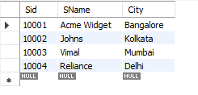

select * from Parts_157;

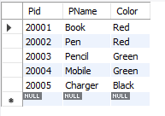

select * from Catalog_157;

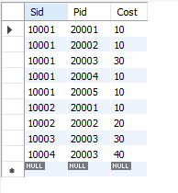

select distinct p.pname

from Parts_157 p, Catalog_157 c

where p.Pid = c.Pid;

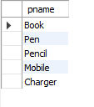

select s.SName from Supplier_157 s

join Catalog_157 c on c.Sid=s.Sid

join Parts_157 p on p.Pid=c.Pid GROUP BY c.Sid

HAVING COUNT(DISTINCT c.Pid) = 5;



select distinct s.SName

from Catalog_157 C, Supplier_157 s

where C.Sid=s.Sid and

NOT EXISTS (select P.Pid from Parts_157 P

where P.color="Red" and NOT EXISTS (select C1.sid from Catalog_157 C1

where C1.Sid = C.Sid and C1.Pid = P.Pid and P.Color="Red"));

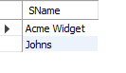

select p.PName

from Parts_157 p, Catalog_157 c, Supplier_157 s

where p.Pid=c.Pid and c.Sid=s.Sid and s.SName="Acme Widget"

and NOT EXISTS (select * from Catalog_157 c1, Supplier_157 s1

where p.Pid=c1.Pid and c1.Sid=s1.Sid and

s1.SName != "Acme Widget");

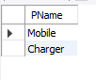

select distinct C.Sid from Catalog_157 C

where C.Cost > (select AVG(C1.Cost)

from Catalog_157 C1 where C1.Pid = C.Pid);

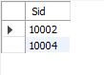

select P.Pid, S.SName

from Parts_157 P, Supplier_157 S, Catalog_157 C

where C.Pid = P.Pid and

C.Sid = S.Sid and

C.Cost = (select max(C1.Cost)

from Catalog_157 C1

where C1.Pid = P.Pid);

